Asimov, Computer Crimes and Capers, Viking 1985 UK reprint. As new dust jacket unclipped with price Pounds 10.95 net. Some small chips at top of spine. As new hardcover with all 253 pages tightly bound with no marks of any kind. 8vo, art by Chris Moore. ISBN 067080097X
In these nine stories computers appear as both the abused and as abusers. Among the writers represented are Robert Silverberg, Joe Cores, Edward Wellen, Edward Hoch, Gordon R. Dickson, Stan Dryer, J.T. Mcintosh and Isaac Asimov.
Of all the technology advances made in recent years (1985), the computer is the most revolutionary. Already it is beginning to transform whole areas of our lives, not least in the dangerous world of crime. Able to shift money bloodlessly, to check identities instantly, and to perform many other invaluable tasks, the computer may help to eradicate certain kinds of criminal activity too.

ID 000327 Price $35 Box 5

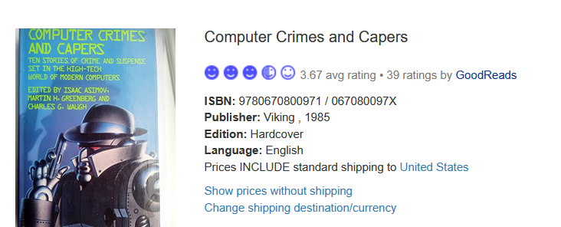
Book Finder Amazon $23

AbeBooks has only softcover $2.00 to $35, New $71.00

